**Best Laptop 2-in-1 Under $700**

____________________________________________________________________________________

Do you want to have the best 2-in-1 laptop? Which is multitasking, time-saving, easy to carry, convenient, and most crucial is an affordable laptop. PCs and laptops are now gradually considered old-fashioned for many reasons. The first and foremost reason in this rapidly developing technological era is that people want to save money and time.

So, for these reasons, the best 2-in-1 laptops are perfect for students, business people, streaming, and gaming—an ideal combo for the people who want to save money and time. The states also show that 11% more than average a person spends on a laptop in the US is $630, so why not go for reliable brands.

Therefore, we did some research for you, which is undoubtedly very tough when there is high competition among rapidly growing brands.

2-in-1 laptop:

The best 2-in-1 laptop means it can be used as a tablet and a laptop, or we can say as a PC. It is easy to carry and a storage house much better than a PC.

Furthermore, we need to purchase a handy laptop or a PC for our other tasks separately, but this 2-in-1 laptop has sorted out our problems. It is easy to take it anywhere in offices, for students, gaming, and streaming.

The world was going crazy when Microsoft launched a new Windows version. As a result, it made all the brands produce a touch screen laptop with a hinge in the middle to rotate in 360-degree easily convertible a laptop into a tablet, and its keyboard can be converted into a stand.

And yeah, what makes it the best 2-in-1 laptop, is its touch system with a pen. Its sleek and stylish modern convertible look makes it more attractive.

**Buyer’s Guide/What You Need to Look Before Buying the Best 2-in-1 Laptop under $700:**

Before you go to buy the best 2-in-1 Laptop, you must check out the following things that are very crucial. This guide will help you find the best item in the market according to your needs.

If you are a budget-restricted person, then follow the guide to understand a better about devices of different brands and their specifications, as well as they must fulfill your requirements.

1. **Processor**

The essential feature depends on one question, for what purpose will you buy this? Gaming, streaming, Business purpose in office or just for basic tasks. You need to buy an Intel Core i5 or AMD Ryzen 5, but if you want to buy it for primary purposes, you can go for Intel.

Core-i3; otherwise, the Intel Core i5 or AMD Ryzen 5 is the best option.

1. **RAM**

Another factor is RAM, and you should prefer at least 8GB which is crucial because less than 8GB is also available in smartphones, and above 8GB is essential for gaming and other stuff like that.

1. **Storage**

We are always concerned about storing much more data for a long time, so the formula is to find out the size of your file and multiply it by the time each file takes to get storage.

For a smoother and lag-free experience, always prefer a device that comes with SSD and don’t go only for HDD devices. However, gamers and graphic designers could need a storage minimum of up to 512GB and a maximum of various TBs in a device.

1. **Display**

It’s wrong to expect a high-quality Display from devices with a low budget. But it would be best if you went for at least a better display that doesn’t distort while editing or any other tasks so you could have joy doing your job.

1. **Reliability**

The durability of a device should be the priority, though the latest models are reliable and are unbreakable. You should always buy a sturdy and durable one that can go for a long because commonly used features like keyboards or devices with convertible features quickly deteriorate. It should be efficient enough and durable

1. **Battery**

When we talk about a battery, nobody, even a child, doesn’t want a device that runs out after an hour. Here we have a list of devices that have a long battery timing.

You can feel it when you are away from the socket doing some crucial and urgent task, and suddenly, your device runs out of battery. Felt it! Then go for a device with the most extended battery.

So now, without further delay, let’s dive into our Top Picks and find out what makes them most appealing to us. I hope this article will help you get the best 2-in-1 laptop for under $700.

We have a list of many more devices for you, but one thing to ensure before purchasing is that their prices change from time to time. Here we go with our top picks,

**Top Picks:**

**Newest Dell Inspiron**

Intel Core i5, 1 GHz, Quad-Core Processor

**HP Pavilion X360**

Available with Intel Core i5, 4.2 GHz

**Lenovo Flex 14-inch**

2.1 GHz AMD Ryzen 5 4500 CPU

**SAMSUNG Galaxy Chromebook**

1.6GHz Intel Core i5-10210U

**Best Laptop 2-in-1 Under $700:**

**1. Newest Dell Inspiron – Best 2-in-1 Laptop Under $700:**

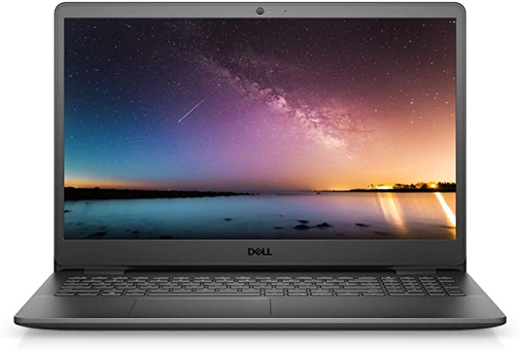

The newest Dell Inspiron Intel Core i5 is the best for office work and business people. Dell is always a reliable brand, and the finest products have been launched. It is appealing with its sleek look and incredible machinery.

The newest Dell Inspiron 15- 3000 3501 Laptop is integrated with a 15.6” Full HD and 1080P screen. Furthermore, its beauty is captivating with an LED-backlit with IPS technology. Its attractive feature is that it has a fantastic battery life of about 11 to 12 hours—a perfect combo for students and business people to work late at night or study.

Our top pick includes 16GB DDR4 and 256GB SSD storage; its storage allows to run multiple apps simultaneously, and its SSD allows to bootup and data transfer faster. It doesn’t stop here; it comes with Windows 10 Home operating system.

It excels as a budget laptop that can handle day-to-day tasks and some very light gaming. Ports and Operating System includes 2 x USB 3.1, 1 x USB 2.0, 1 x HDMI, 1 x Combination Audio Jack, 1 x Multi-format SD Media Card Reader; Wireless-AC + Bluetooth Combo; Windows 10 Home 64-bit.

**Specs:**

* Brand: Dell
* Series: Inspiron
* CPU: 11th Gen Core i5-1135G7 Quad-Core Processor
* Processor: 1 GHz
* Display: 15.6 inches FHD Anti-glare LED-backlit
* Operating System: Windows 10 Home 64-bit
* Weight: 5.7 pounds
* Screen Resolution: 1920 x 1080 Pixels
* RAM: 16GB DDR4
* Graphics coprocessor: Intel UHD Graphics
* Hard Drive: 1TB SSD
* Memory speed: 3.6 GHz
* Chipset Brand: Intel
* Wireless: Bluetooth, Wi-Fi
* Processor count: 4
* Product Dimensions: 14.33 x 9.8 x 0.78 inches
* Power source: Battery Powered, 3-Cell 42 WHr
* Battery life: 11 to 12 hours
* Audio: Stereo speakers
* Display Technology: LED
* Media Drive: Multi-format SD Media Card Reader
* Video: Intel Iris Xe Graphics
* Ports: DisplayPort, Type-A, C, HDMI, 2 x USB 2.0

**Pros:**

* Storage capacity is high
* Fast processor
* Excellent in performance
* Lightweight
* Fan is quiet.
* Long battery life
* High-Quality display
* Budget-friendly
* Multiple ports

**Cons:**

* Display is average
* No touch-screen
* No backlit keyboard
* Not a gaming laptop

**2. HP Pavilion X360--Best Convertible Under $700:**

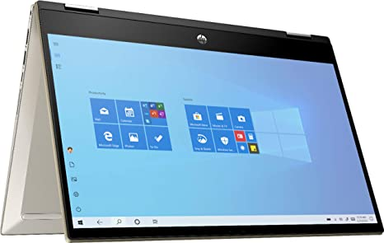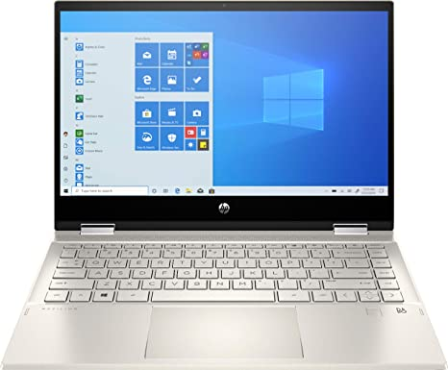

The HP Pavilion X360 is the best convertible laptop under $700, is stylish, sleek, and comes equipped with a stylus. It has a dark interior with a silver lid. With an appealing look, a vibrant display shows as creations are brought to life with 14” diagonal Full HD (1920 x 1080) multi-touch-enabled with an edge-to-edge display.

It has a faster processor with 4.2 GHz; the Intel Core i5 1135G7 CPU works efficiently. It is easily convertible into a tablet, one of the best 2-in-1 Laptops with a quick touchpad, and its keyboard keys are perfectly designed, not too big or small.

It is integrated with 8GB RAM DDR4 and a 256 GB SSD on the storage front, working without lagging. If you open multiple tabs or apps, it works efficiently. It shows zero lag. Even if you run Adobe software for editing or open various tabs, it would not lag or slow down. While it offers many appealing features, it is not suitable for gaming because of medium graphics up to 40 to 50 fps. It has eye-catching graphics- Marvel at crystal-clear imagery with Intel Iris Xe Graphics.

The best 2-in-1 laptop under $700 comes with long battery power for long-term streaming, and battery timing is up to 8 hours of wireless streaming capabilities. Not only this, it gets charged faster in approximately 45 minutes or 1 hour, which is just excellent and more than enough.

A trustworthy laptop equipped with Windows 10 Home operating system and built-in dual speakers boost up sounds of music, movies, and games.

There is a single M.2 port for storage. If you want, you can replace the 256GB drive that comes with the laptop with a different storage drive of your choice, and it would work perfectly.

**Specs:**

* Brand: HP
* Series: 14-dw1024nr
* Display: 14-inches
* Resolution: 1920 x 1080 pixels
* CPU Model: Core-i5
* Operating system: Windows 10 Home
* Processor: 4.2 GHz
* RAM: 8GB
* Hard drive: 512GB SSD
* Graphics Coprocessor: Intel Iris Xe Graphics
* Card Description: Intel Iris Graphics card
* Chipset Brand: Intel
* Wireless type: Bluetooth, Wi-Fi 802.11ax
* Battery life: 9- 10 hours
* Weight: 3.33 pounds
* Dimensions: 12.76 x 8.7 x 0.71 inches
* Batteries: 1 Lithium Polymer Batteries

**Pros:**

* Audio is of great quality
* Excellent convertible screen
* Long battery life
* High-quality

**Cons:**

* Touchpad occupied much space
* No backlit keyboard

**3. Lenovo Flex 14 inch- The Best 2-in-1 Laptop:**

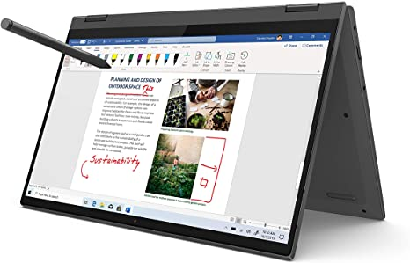

The best 2-in-1 Laptop, Lenovo Flex 5 14” display, is thin, stylish, and light, weighs only 3.64 pounds, and thickness is just 0.82”. This masterpiece is reliable soft, and comfortable. It comes with a digital pen that is durable.

It revolves 360 degrees with a slight push. The 10-point 14”- FHD (1920 x 1080) IPS touchscreen of a Lenovo Flex 5 is easily convertible. This stylish model is integrated with AMD Ryzen 5 4500U CPU, making it speedy and multitasking.

It is equipped with AMD Radeon graphics that perform multitasks and enable it to play movies, any productive task, gaming, study, and content creation even at 10% battery consumption per hour. The brand’s claim is not just buttery talk of 10hours battery life with short span charging in just 1 hour.

One top magical feature is its 360 degrees hinge lets you use this 2-in-1 touch screen laptop in different modes, such as everyday ‘laptop’ mode; it is convertible in ‘tent’ mode for sharing things, you can watch movies and stuff in ‘stand’ mode and last but not the least in ‘tablet’ mode for different intuitive interactions.

It is excellent, stylish, comfy, and quite handy when you are fed up with touchpads, you can utilize the option of a digital pen, and then you can use a keyboard in laptop mode.

**Specs:**

* Brand: Lenovo
* Series: flex 5 14-inches
* Hard disk: 256GB
* RAM: 16GB
* Operating system: Windows 10 Home
* Weight: 3.63 pounds
* Processor Brand: AMD
* Processor Count: 1
* Display: 14-inches
* Resolution: 1920 x 1080 pixels
* Dimensions: 12.66 x 8.56 x 0.82 inches
* Memory speed: 2.1
* Graphics Coprocessor: AMD Integrated Graphics
* Chipset Brand: AMD
* NO. of USB 3.0 Ports; 2
* Card description: integrated
* Battery life: 10 hours
* Wireless type: Wi-Fi 802.11ac
* Batteries: 1 Lithium Polymer Batteries

**Pros:**

* High quality of 360 degrees Hinge
* Amazing pixels
* Excellent display
* Smoothly convertible
* Super battery life
* Superior Sound quality

**Cons:**

* Backlit keyboard is not included
* Touchpad took an ample space

**4. SAMSUNG Galaxy Chromebook best 2-in-1:**

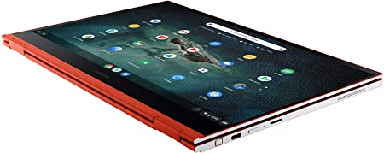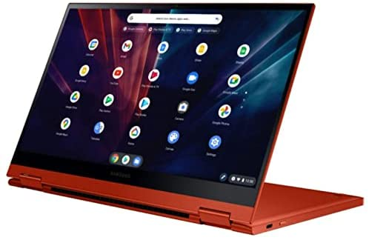

Samsung Galaxy Chromebook 2-in-1 is the best laptop under $700, a device that you won’t regret buying. On top of that, a brand that is trustworthy and award-winning. Furthermore, you experience vivid colors, high quality and fully bright screen, contrast, and depth with a 4K AMOLED touch screen that takes you to another level of fun and joyful work. If we go for Storage, you get ample storage of 256GB SSD, which boosts faster in seconds and quick access while multitasking.

Let’s dive into its beauty and digital pen that fits perfectly to the demands and needs of sketchers; editors can work accurately with a built-in pen with its sleek, stylish, and ultra-slim design. It is speedy, with a secure operating system.

It is designed in a helpful way to run many apps. You can watch shows, and movies, play games, edit, sketch, and do any task with Google Play store apps. It comes with Google Assistant, which can control and help you multitask. Intel's high-performance hardware lets you get more storage, work with speed, smoothly run multiple apps, and download anything faster.

**Specs:**

* Brand: SAMSUNG
* Series: Galaxy Chromebook
* Display: 13.3 inches
* Resolution: 3840 x 2160 pixels
* Color: Red (variety in models)
* Hard Disk: 256GB SSD
* CPU Model: Core i5-10210U
* RAM: 8GB
* Card Description: Integrated
* CPU speed: 1.6 GHz
* Operating system: Chrome OS
* Weight: 2.29 pounds
* Dimensions: 11.92 x 8 x 0.39 inches
* Processor Brand: Intel
* Processor count: 1
* Flash Memory size: 8
* Voltage: 7.7 volts
* Wireless type: Bluetooth, 802.11ax Wi-Fi
* Average battery life: 8 hours
* Display Technology: AMOLED
* H Interface Input: touchscreen with Stylus support

**Pros:**

* Budget-friendly
* Better battery life
* Minimal and Modern Look
* Light weighted
* Speedy and stylish
* No lag
* Stable Chrome OS and speedy

**Cons:**

* Windows Compatible Apps are not easily accessible to students
* Limited capabilities of apps due to online Cloud Storage and Web-based apps

**5. Lenovo IdeaPad3 Best 2-in-1 Laptop Under $700:**

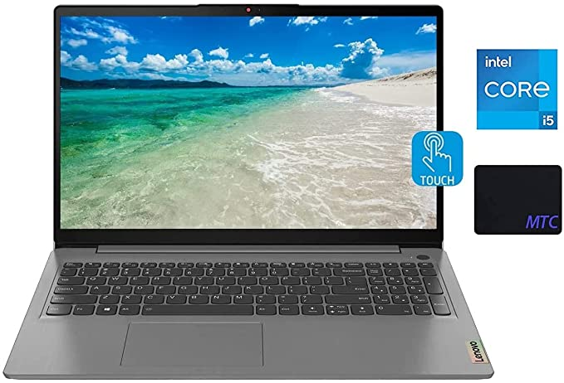

Lenovo Idea pad 3 is considered one of the best 2-in-1 laptops, with a 15.6” Full-HD point multi-touch display of 1920 x 1080 resolution, unique colors, and clarity. It is integrated with an efficient LED backlight and IPS technology for wide angles, its thin and light design is easy to carry on tasks.

It includes a Quad-Core Intel Core i5- 1135G7 processor with ultra-low voltage performance and its eight-way processing gives an efficient, powerful performance with the speed of 2.4 GHz frequency. On top of this, it comes with 12GB DDR4-3200MHz RAM, and a 256GB SSD that can run all games, programs, movies, and editing programs smoothly and lag-free.

Yeah, even you can run multiple tabs, and apps and multitask at a time. It is designed stylishly with a lighter weight and rigid frame which is easy to carry. A complete packaged 2-in-1 laptop, where you won’t stop loving your job when a hands-on backlit keyboard, and nothing can stop you.

**Specs:**

* Brand: Lenovo
* Model: IdeaPad 3
* Operating system: Windows 11 Home
* Weight: 74 pounds
* Display: 15.6 inches
* Resolution: 1920 x 1080 pixels
* RAM: 12GB
* Processor Brand: Intel
* Processor Count: 4
* Dimensions: 14.26 x 9.98 x 0.78 inches
* Memory speed: 3200 MHz
* CPU speed: 2.4 GHz apple-Corei5
* Graphics Coprocessor: Intel Iris Xe Graphics
* Chipset Brand: Intel
* Hard Drive: 256GB SSD
* Wireless type: Wireless-AX, Bluetooth
* Keyboard: Backlit keyboard
* Screen: Touch screen
* Ports: USB (3.2, 2.0, C), HDMI, Audio jack, MCR

**Pros:**

* Amazing performance
* USB type C is included
* You can add more storage drive
* Backlit keyboard
* Comfortable keyboard and touchpad
* Amazing feature is Fingerprint Scanner
* Budget-friendly

**Cons:**

* Display colors issue
* Speaker’s sound quality

**6. Newest Flagship Acer R13 Top Best 2-in-1 Laptop:**

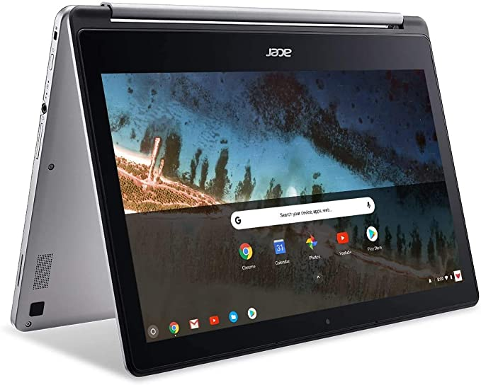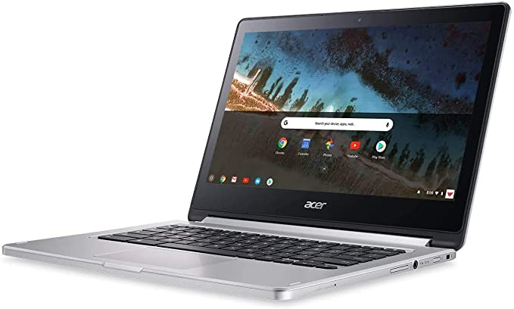

Newest Flagship Acer R13 with 13.3” convertible 2-in-1 Full HD IPS Touchscreen Chromebook, Intel Quad-core Mediate Multiprocessor that is designed in a modern way with its automatic virus protection system and faster speed that boots up in few seconds.

On top of this, it is a standard quality that runs the Google Play store and you can run all google apps with Microsoft programs, various games, movies, TV, Books, and many more options to avail. Because this Chromebook runs on Chrome OS by Google. Furthermore, it is available with a long Battery life of up to 12-hours, a 10-point multitouch screen, with 4GB RAM. It gets charged faster. A Standard Keyboard is included.

The best 2-in-1 Laptop offers a smart and stiff look with stability in its convertible look. It includes a microSD card reader. It steals all the attention with its simple, sleek, and stylish look. Yet it is better in a way that you can use it as a tablet or as a laptop furthermore, you can have all the other features that are available in smartphones.

**Specs:**

* Brand: Acer
* Series: Chromebook
* Operating System: Chrome OS
* Weight: 3.28 pounds
* Processor Brand: Intel
* Processor Count: 2
* CPU Model: Intel Quad-Core
* CPU speed: 1.8
* Display: 13.3-inches
* Display Technology: LED
* Hardware Platform: Chrome
* H Interface Input: touchscreen
* Dimensions: 12.83 x 8.89 x 0.61 inches
* RAM: 4GB
* Hard Disk: 64 GB SSD
* Card Description: integrated card
* Graphics Card RAM size: 2 MB
* Wireless type: Bluetooth, 802. ac
* Battery life: 12 hours
* Memory speed: 1600 MHz
* No of USB 3.0 Ports: 1

**Pros:**

* Modern and stylish look
* Touchscreen
* It runs all Google apps
* It Runs android apps also
* Long battery Life
* Minimal and sleek design
* Multitasking capability

**Cons:**

* Audio is not standard sometimes
* Average performance
* Gets Hot while Charging

**7. Lenovo Yoga C-740 The Best 2-in-1 Laptop Under $700:**

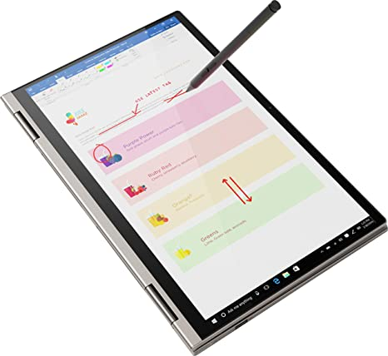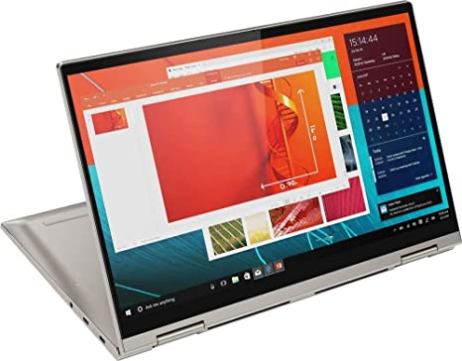

One of the best 2-in-1 Laptops is Lenovo Yoga C740, it works faster, is smoother, and is highly efficient. It is not a gaming laptop or a pro device but you can use it for study, or everyday tasks. Its keyboard contains a backlight that makes you work in a dark room which is perfectly fine. This 14” FHD (1920 x 1080) IPS 300nits Anti-glare touchscreen Display from a 10th Gen Intel Core i5-10210U comes with a fast processor that boots up in a few seconds with a speed of 1.6 GHz up to 4.2 GHz. It is not over yet, its 360-degree hinge makes it easily and smoothly flip which makes it useful as a tablet, a laptop, as a stand, or as a tent for sharing data. The device is integrated with a full HD display and comes with a digital pen which is fine in its working. On the storage front, it won’t be much appealing but can go for a daily purpose. You can enjoy all its features with the addition of a fingerprint scanner.

**Specs:**

* Brand: Lenovo
* Series: C740-14
* Hard Disk: 256 GB
* CPU Model: Core-i5-10210U
* RAM: 8 GB
* Operating system: Windows 10 Home
* Graphics Coprocessor: Intel UHD Graphics
* CPU speed: 1.6 GHz
* Display: 14-inches
* Resolution: 1920 x 1080 pixels
* Chipset brand: Intel
* Weight: 3.09 pounds
* Processor count: 4
* Battery life: 13 hours
* Wireless type: 802.11ac
* Batteries: 1 Lithium-ion Battery

**Pros:**

* Ports are included in a good area
* Fingerprint scanner
* Works with fast speed
* 360-degrees flip
* Webcam is fantastic
* Build-in is amazing

**Cons:**

* Speakers sometimes distort
* Dolby Atmos software is not good

**8. Acer Spin 3 Best Convertible Laptop 2-In-1 Under $700:**

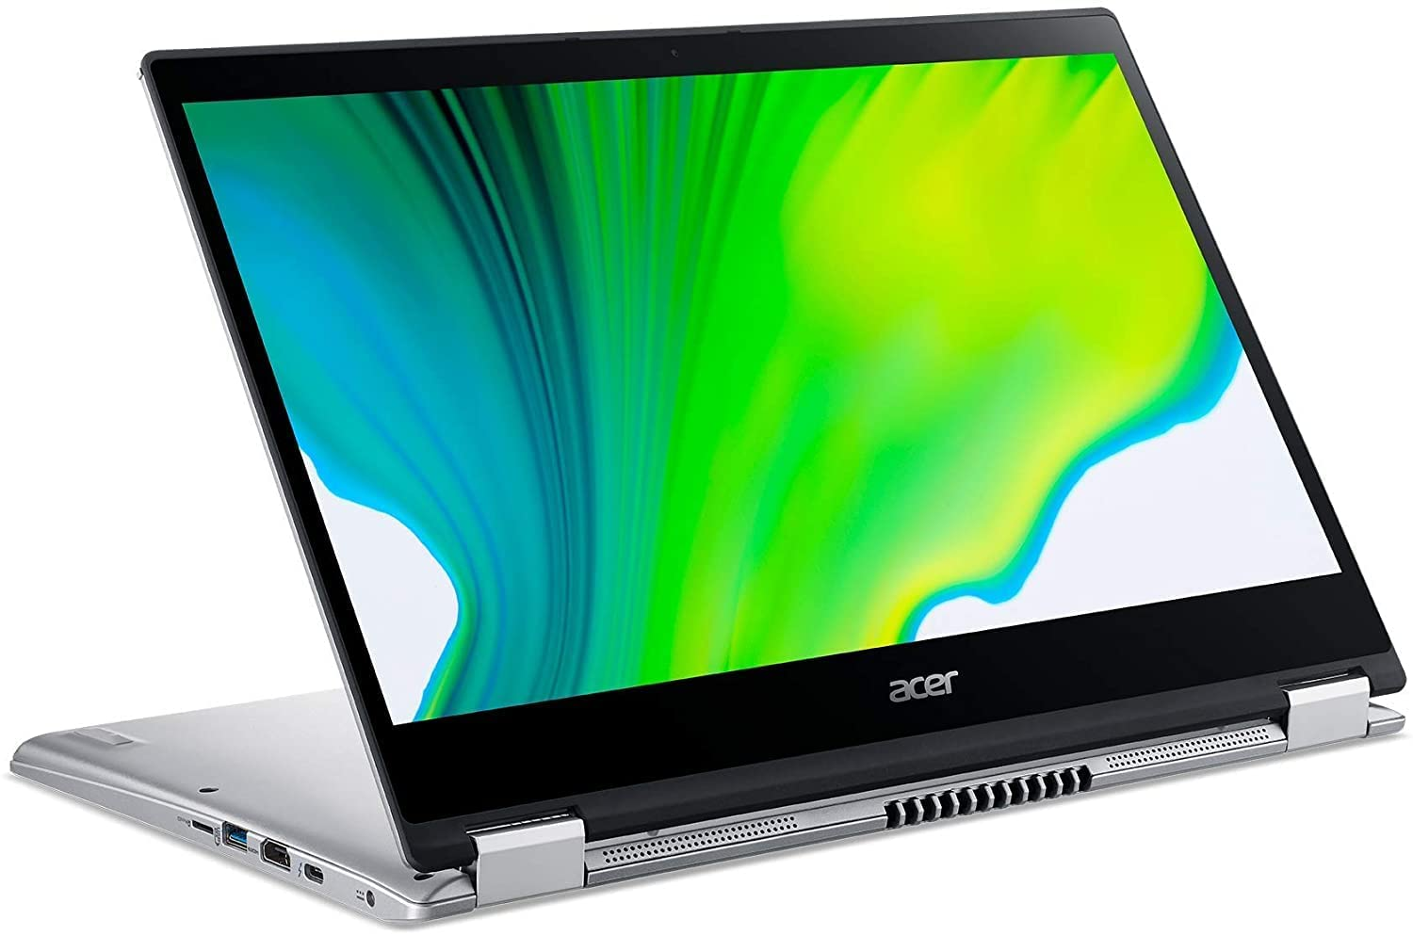

The best 2-in-1 convertible laptop is equipped with high graphics and can bear heavy workloads. It is a perfect imagination into reality, let’s dive into its features and discover what we have gathered after research for you so, you won’t find it difficult to get the best laptop for your work.

However, it is a difficult task to gather the best items in a huge competition. The first and foremost feature is its 360-degree rotation while you are working for a long time and you get tired then it’s a perfect handy item that you can convert into a tablet mode and whenever you want it to touch with its high-quality touchpad.

Furthermore, you can use its digital pen available with it so it’s a perfect moody and handy device to go with its fast processor which is an Intel 10th Gen i5 with the storage of 8GB and 512GB SSD. Its processor has 8 thread 4 core that makes it fast so it boots up in seconds.

You can run any software and program like Adobe Premiere etc. It has an integrated graphics card because you’ll feel a slight lag while running multiple apps, that is the main issue with an integrated graphic which is always slower as compared to dedicated cards.

It is available with a stylus and a better display color a bit low range than a wide color gamut. It is a perfect device for students and an editor for the programs like photoshop.

On top of that, it has a great battery life, you can work for extra hours with its GPU more than its limit. The best 2-in-1 convertible Laptop under $700 is no doubt the best, durable, with ample storage and battery in this budget.

**Specs:**

* Brand: Acer
* Series: SP314-54N-58Q7
* Operating system: Windows 10 Home
* Weight: 6.74 pounds
* Dimensions: 19 x 12 x 3 inches
* Processor Brand: Intel
* Processor count: 2
* Display: 14 inches
* Resolution: 1920 x 1080 pixels
* Processor (CPU) speed: 1 GHz Core-i5
* RAM: 8GB
* Hard Drive: 256- 512GB SSD
* Graphics coprocessor: integrated Graphics
* Chipset Brand: Intel
* Wireless type: Bluetooth. Wi-Fi
* H Interface Input: Touchscreen
* Ports: USB 3.1, Gen Type C, Thunderbolt port
* Keyboard: backlit keyboard

**Pros:**

* Backlit keyboard is its beauty
* Fast speed
* Multitasking capability
* Durable and powerful
* Amazing battery life with clock GPU
* Stylus is included
* An addition of a Fingerprint scanner

**Cons:**

* Its display colors are slightly whiter and not radiant as compared to other

**9. ASUS VivoBook Flip – Best 2-in-1 Under $700:**

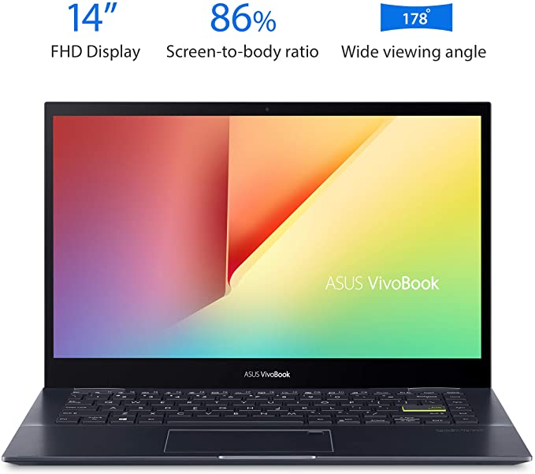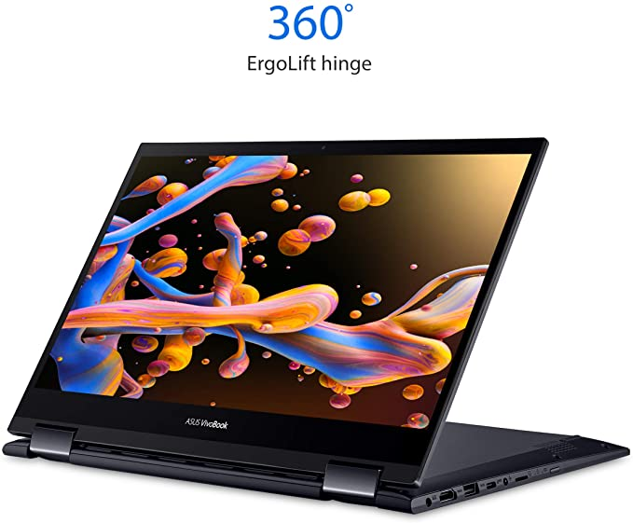

The best 2-in-1 convertible ASUS VivoBook Flip is no doubt an awesome device with a powerful and efficient AMD Ryzen 7 5700U Processor with a speed of 4.3 GHz and 8 cores.

At first glance, it seems it won’t rotate but Yes it flips 360-degrees with hinges and is easily convertible in any mode of a tent, tablet, stand, or Laptop. It is available with a 14” wide FHD Touch Display.

It comes with a stylus and holder. A thin and lightweight with a stunning 82% screen-to-body ratio, brushed aluminum chassis.

It is integrated with AMD Radeon graphics which can run mid to low range of games because it is not a gaming laptop but have a slight to mid ability to run at a good pace. In connectivity, it has USB port 2.0, 3.2 with HDMI port, and Type C.

with a super-fast touch screen and a 178-degrees viewing angle optimized for entertainment. A luxurious model which is no doubt a beast in its specifications, what else one could have under a $700 budget. It is no doubt more than enough.

**Specs:**

* Brand: ASUS
* Series: TM420UA-DS71T
* Operating system: Windows 10 Home
* Weight: 3.31 pounds
* Dimensions: 12.76 x 8.66 x 0.72 inches
* Processor Brand: AMD
* Processor: Ryzen 7
* Processor speed: 2GHz
* Processor count: 1
* Display: 14-inches
* Resolution: 1920 x 1200 pixels
* Graphics coprocessor: AMD Radeon TM Graphics
* Card Description: Integrated
* Wireless type: 802.11ac, Bluetooth 4.2
* No of 2.0 ports: 1
* No of 3.0 ports:1
* RAM: 8GB
* Hard Drive: 512 GB SSD
* H Interface Input: Touchscreen with stylus

**Pros:**

* Amazing performance with AMD CPU
* Super-fast Touchpad and keyboard
* Comfortable deice to go with
* Stylish and modern
* Storage with high speed
* Powerful and efficient

**Cons:**

* Linux performance is disappointed

**10. Newest 2022 ASUS Chromebook Flip – Top Best 2-In-1 Under $700:**

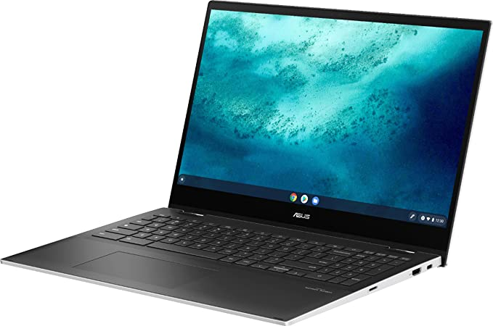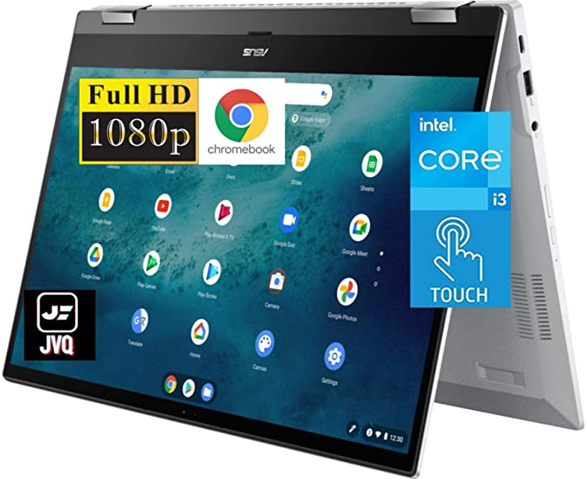

The newest ASUS Flip Chromebook 2-in-1 touchscreen laptop is one of the top best laptops. This business model is like a beast under budget with a multitasking feature.

If we talk about its display which is a 15.6” wide FHD Touch Screen with 1920x1080 resolution, amazing color clarity, and bright and radiant display. It is equipped with backlit LED and Graphics Intel UHD 600, which makes it an impressive and ideal for students, business professionals, commercial purposes, online learning programs, and many more fields can use it with the comfort of its Touchpad and flip feature.

It is easily convertible in any mode and style which makes it appealing to the eyes of every field. This beast is a powerful, and super-fast 11th Gen Intel Core i3 processor which boosts up in seconds with a speed of 4.1 GHz. That is an amazing speed.

And if we go for storage which is everyone’s priority, it has 8GB RAM with 128GB SSD Plus 128GB Memory card, an awesome feature to run multiple apps smoothly. Which improves the efficiency of tasks and smoothness while running multiple tabs, and apps.

Furthermore, the keyboard is great and comfortable with backlit to work even in a darker room and never let your performance slow down. It is a beautifully well-designed model.

It comes with Chrome OS so it is easy to run the Google app and store like other Chromebooks. It has a long battery life of a max of 10 hours which is more than enough for this 2-in-1 device.

All in all, it is an amazing and perfect 2-in- 1 convertible model for every field, it is lightweight, sleek, stylish, minimal, well built-in, powerful, and highly efficient with many ports and touchpads, etc. It has a 360-degree, 2-in-1, flip-fold style.

**Specs:**

* Brand: ASUS
* Series: ASUS C536EA
* Operating system: Chrome OS
* Display: 15.6 inches
* Resolution: 1920 x 1080 pixels
* Hard Drive: 256 GB
* RAM: 8GB
* Memory speed: 4.1 GHz
* Graphics coprocessor: Intel UHD Graphics
* No of USB 3.0 ports: 4
* Processor: 3 GHz apple- core i3
* Weight: 4.17 pounds
* Dimensions: 14.08 x 0.48 x 0.73 inches
* Rear Webcam resolution: 720 pixels
* Processor count: 2
* Processor Brand: Intel
* Keyboard: backlit
* Wireless type: Wi-Fi 6, 802.11ax, Bluetooth

**Pros:**

* Efficient and powerful
* Portable and lightweight
* Amazing backlit keyboard
* Amazing battery life
* Stylish and modern
* Flip-fold 360-degrees style
* Comfortable touchpad
* Built-in speakers

**Cons:**

* Not compatible with games
* Not a gaming laptop

**Conclusion:**

The best 2-in-1 Laptops are easy to use and convenient in terms of use as a tablet or as a laptop.

As we have provided a complete guide about 2-in-1 laptops under $700 with their advantages and disadvantages.

All of these models are powerful and highly efficient. On top of this these models are gathered after huge research for your easy pick. If you are budget restricted person then this guide will help you to pick the best 2-in-1 laptop under $700. As we have enlisted our top 10 models with detailed reviews and specifications. We have made it easier for you, so no worries, and go for our top picks.